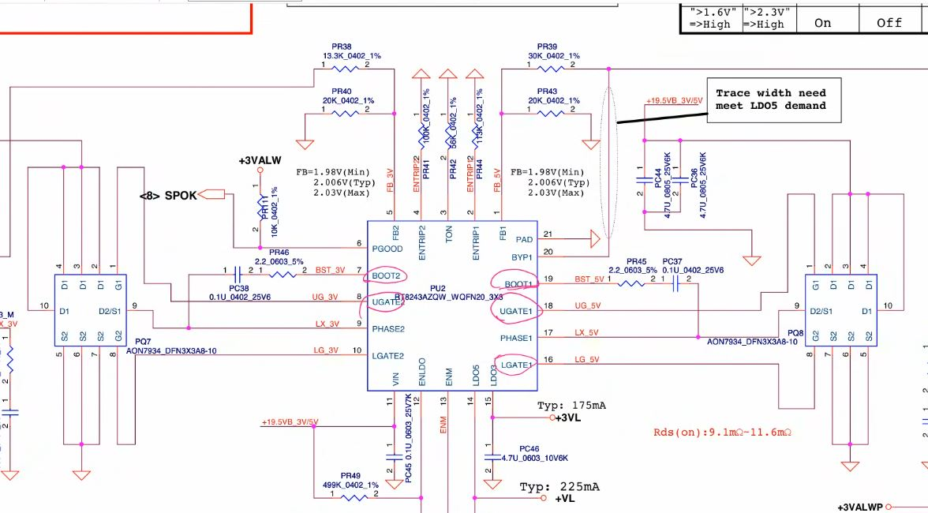Dual 3V and 5V
Check list
- VCC 19 v
- ENLDO By voltage devider
- LDO3/VREG3( send to SIO), LDO5/VREG5 (3VL OUTPUT)/ (5VL OUTPUT)
- ENM (enable master from SIO) 3volt
- ENTRIP1, ENTRIP2
- BOOT1, BOOT2
- UGATE1, UGATE2
- LGATE1(should be low hight(3,4, 5 hoga to switching start nhi hoga)), LGATE2
- PHASE1(mosfet output voltage feedback), BOOT1, UGATE, LGATE – internal process
- FB1
- PGOOD(output pin sending info this department is working fine) 3volt
Note
3/5V Regulator IC - LDO and Switching voltage out krta hai…
Difference LDO – Low ampier and Switching Voltage(VALW) – high empier
LDO (Low Dropout)
StepDown IC se out hota jo kafi jagah jata hai.
Main kaam SIO and PCH ko jagana intialize krna hota hai

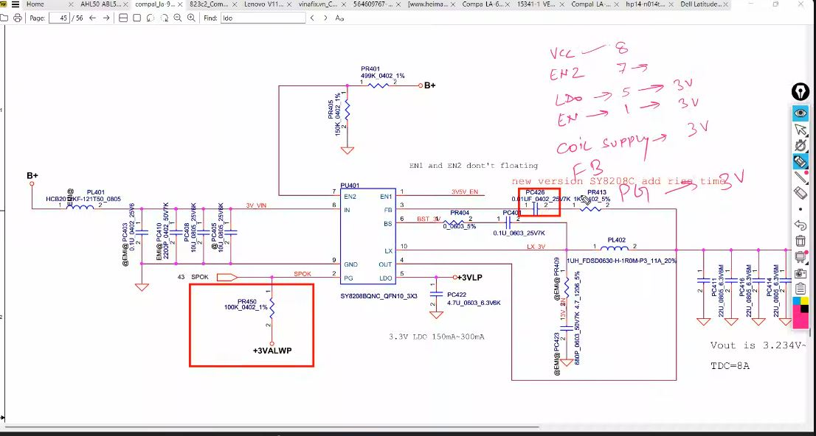
Single IC 3V

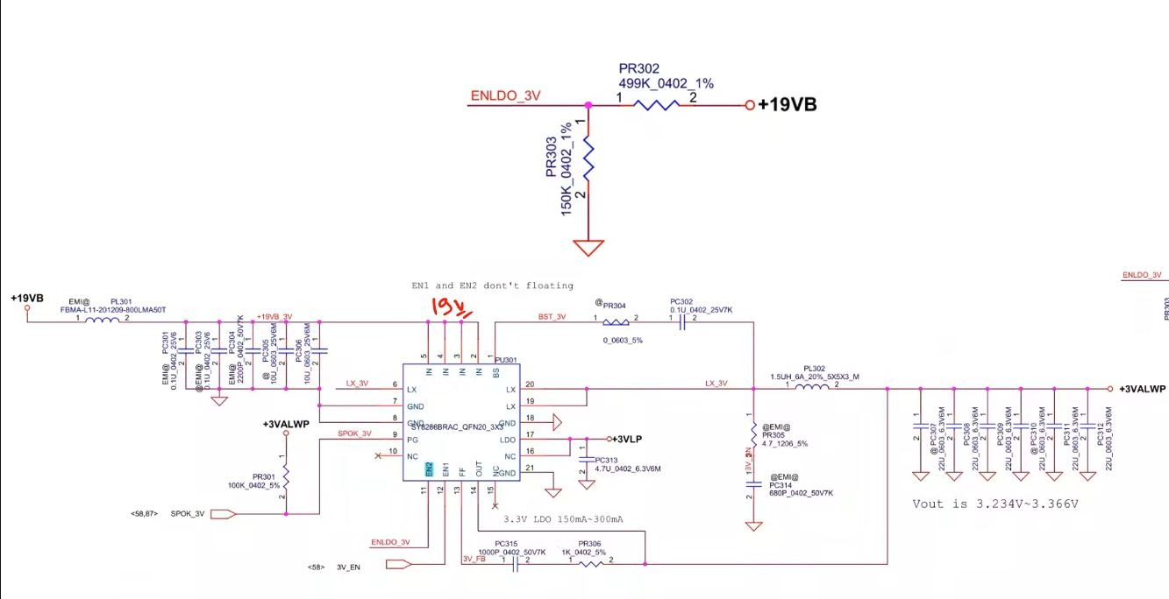

Shortcut to find by enldo
Check List
- In(VCC)
- EN2 (ENLDO)– by voltage devider
- LDO- 3VLP
("+3VLP" refers to a +3.3V Low Drop-Out (LDO) It is a critical, always-on voltage used to power the Embedded Controller (EC) and initialize the system before main power rails activate)
- EN1 ~3volt – (from SIO)
First SIO Requiremet puri karni hai
3VLP distribution search krenge
(issi se on/off hota hai)
Note:
3 volt regulator suppy se pehle LDO banta hai
https://www.youtube.com/watch?v=HUelstoHB3k

